**Practical 1. : Introduction and contribution to Wikipedia**

1. **Description about Wikipedia and its features :**

Wikipedia is a free, open content online encyclopedia created through the collaborative effort of a community of users known as Wikipedians. Originally, Wikipedia was created to provide content for Nupedia.

* Basic features of Wikipedia:

1.Create a page

2. Edit a page

3. linking between pages: Linking between Wiki pages makes it easier for readers to find secondary materials they may need, especially as your Wiki grows.

1. **Creating Account on Wikipedia :**

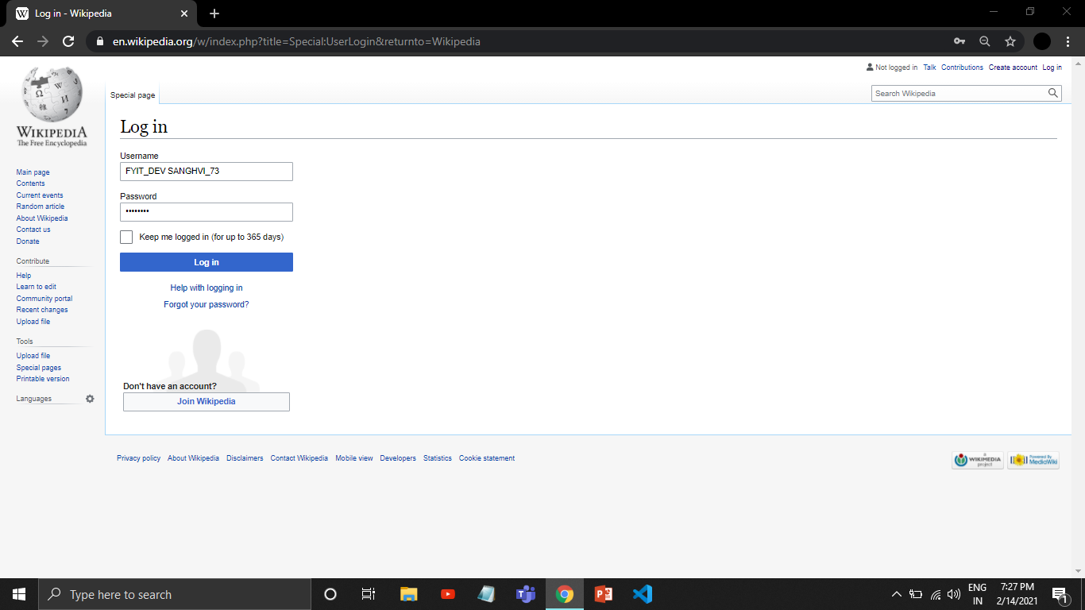

1. If you have an account you can directly log in to access Wikipedia by your account
2. If you don’t have an account then click on join Wikipedia to create an account.

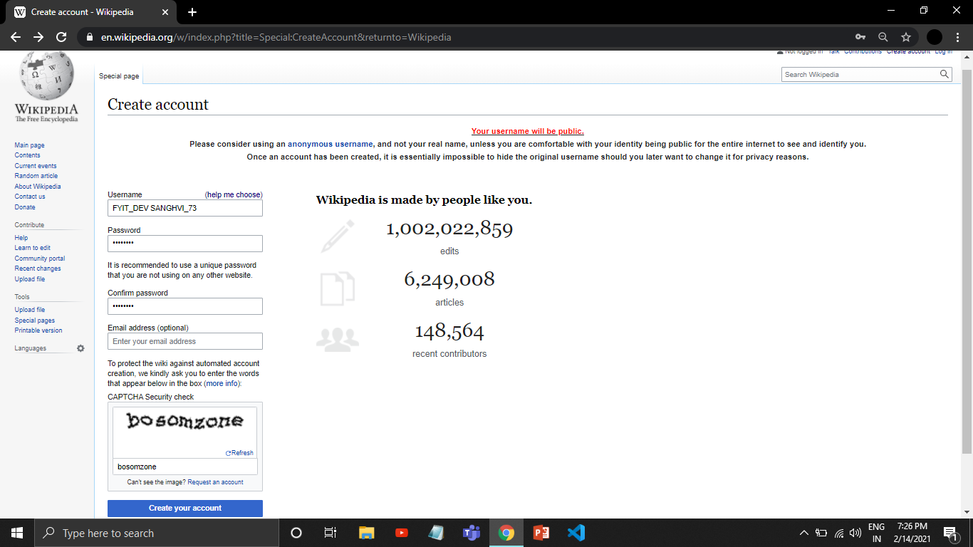

1. Fill the information and click on Create your account after that your page will be created.
2. **Creating your page on Wikipedia:**
3. click on Create source to create your page.

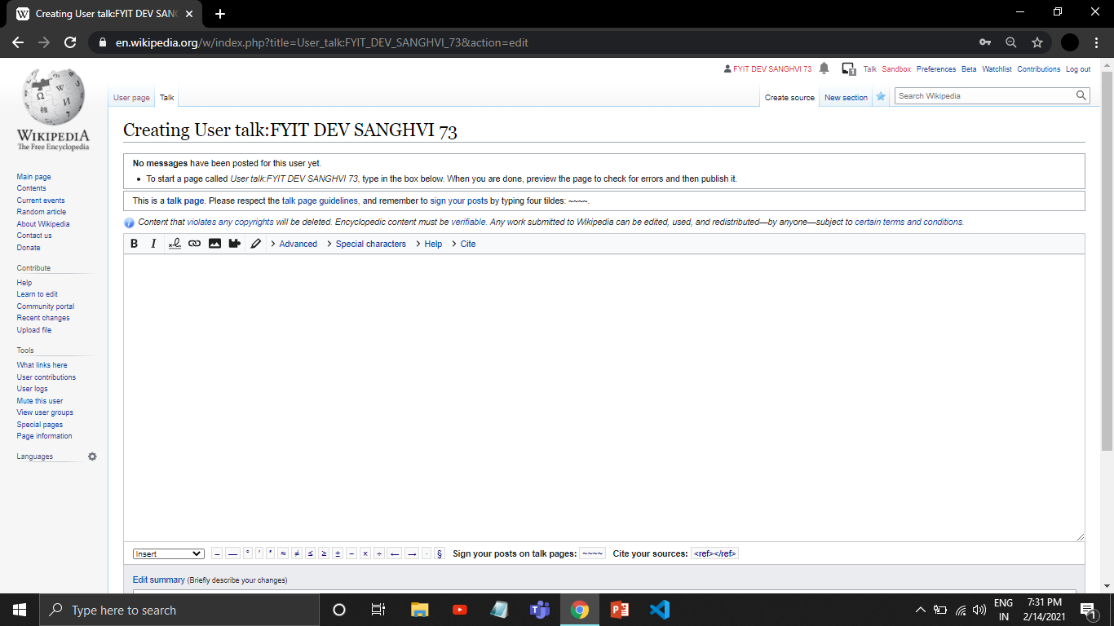

2 .add your content and then click on publish changes to publish your page on wikipedia.

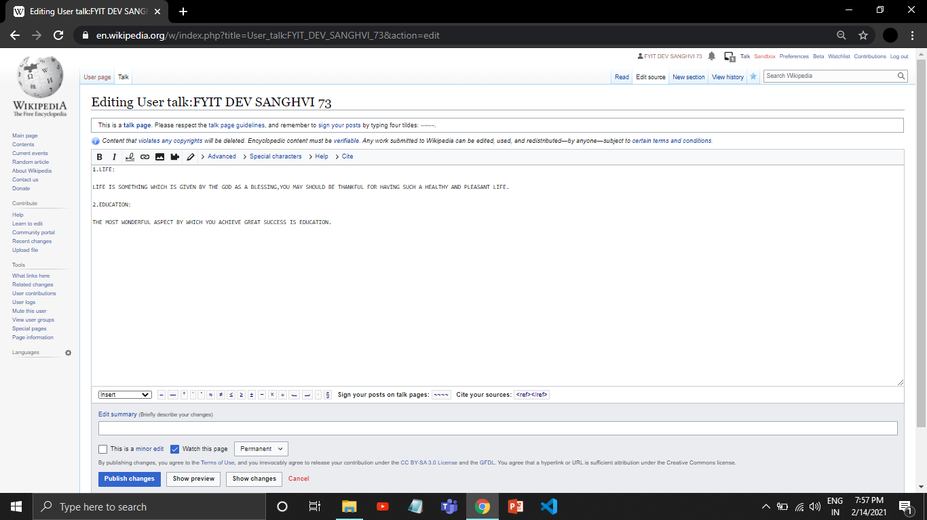

1. **Editing your page on Wikipedia :**

1.click on edit source to edit your page.

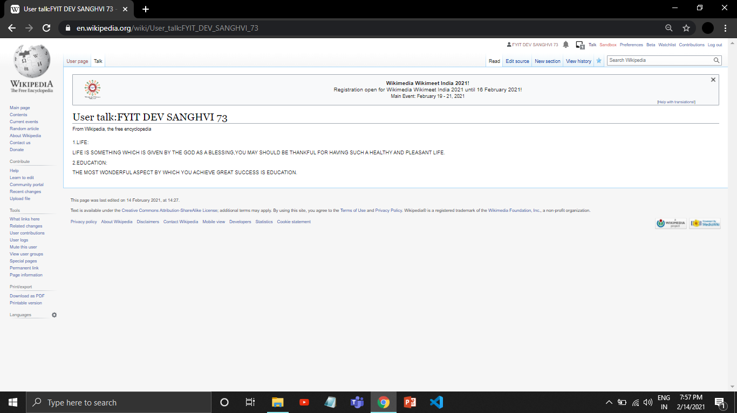

2.edit your changes and then click on publish changes to confirm your edits.

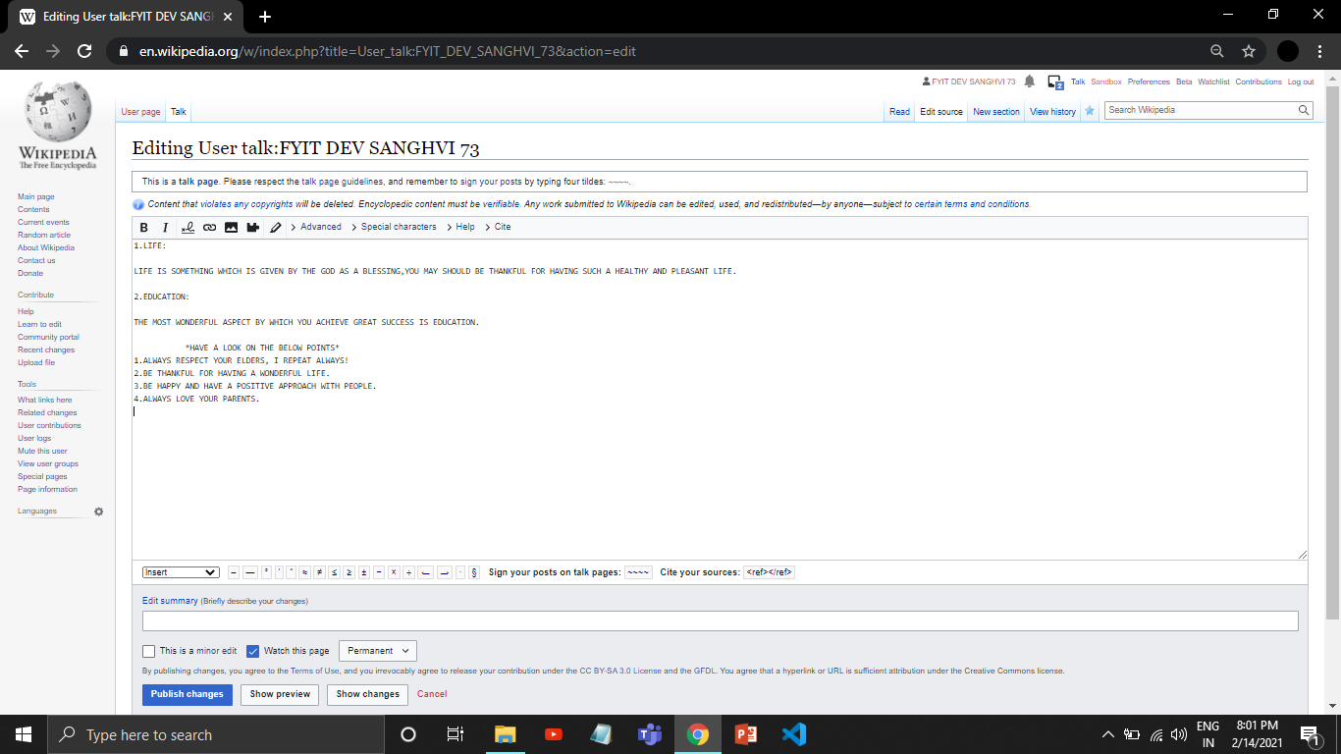

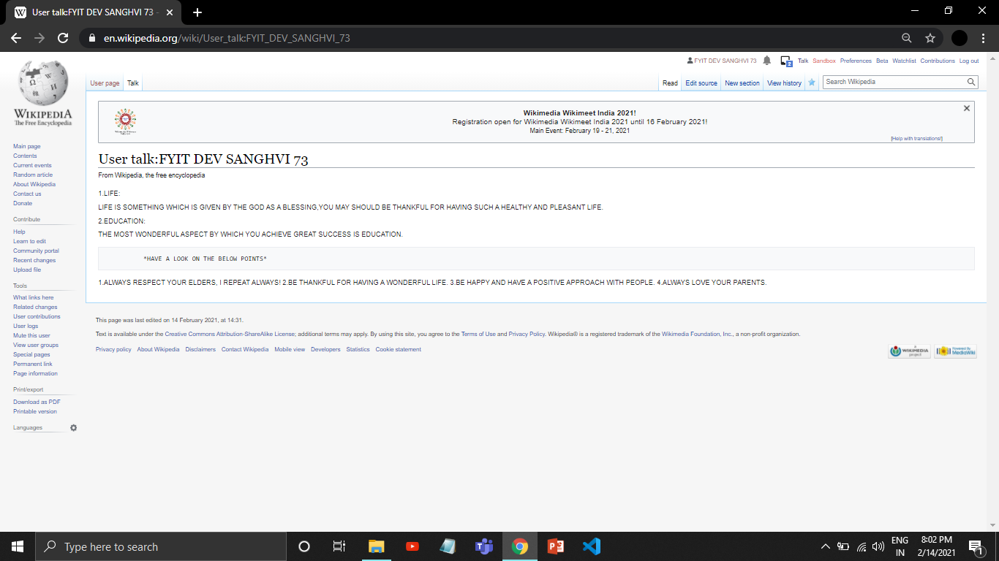

3.Your page will be displayed with the changes.